WEST LONDON WASTE AUTHORITY
Report of the Managing Director | 23 June 2023
WLWA 2022-23 Business Plan

SUMMARY
This report provides details of the Authority’s Business Plan for 2022-23. The key points are:
- The Business Plan 2022-23 was ambitious and challenging and has driven improvements in how we work. We demonstrated excellence in joint working on net zero, collaborative decision making on waste and resources and joint procurements of services and materials. We reduced waste, demonstrated better methods of measuring recycling and created budgets for three new, three year strategic programmes. We measured the social value of reuse projects, procured a social value calculator and presented waste and resources in the context of decarbonisation and net zero.
- The HR Strategy, Joint Plan for 2030, Infrastructure Investment Plan, and Extended Producer Responsibility Strategy have been rolled forward into 2023-24.
- The food waste programme was extended to allow more time for monitoring due to some delays to starting Borough projects. The HRRC programme was rolled forward and has now been delivered in Q1 2023-24. The virtual and Borough Circular Economy Hubs have rolled forward into 2023-24 all with no impact on budget.
- Lessons learned from the Business Plan 2022-23 are that change at this speed is difficult both internally and to maintain alignment with partners as all change at the same time. Joint planning is needed even if government legislation isn’t available yet.
- WLWA can demonstrate progress against the JMWMS agreed framework with reduced waste, reduced total food waste and increased reuse.
RECOMMENDATION(S)
The Authority is asked to:-
- Approve the conclusion of the 2022 Business Plan and roll over of some activities to the 2023-24 Business Plan.

- Background – Since 2019, the Joint Municipal Waste Management Plan has focused on outcomes whilst we wait for clarity on new environmental legislation and regulations and agreed a framework with Boroughs in 2021. The authority has developed and cemented its values of Leadership, Empowerment, Agility and Partnership to create the capacity internally to create these outcomes. In 2021 WLWA published its first annual report, designed to bring together all of the challenges and successes of the previous year. The 2023 annual report will showcase the highlights of the past year as we decarbonise and take climate action.

- The 2022-23 Business Plan was challenging and ambitious and took steps to meet climate change targets by understanding how we can reshape waste services to meet the future needs of legislation. It was a very unsettled period after the COVID 19 pandemic. The table below highlights the key achievements and lessons learned during the year:
A | Resilience and preparation | To be prepared for significant change resulting from legislation and social and economic needs. To remain aligned with our supply chain and Boroughs as all organisations in the resources and waste sector manage significant change.
 | Key Achievements | West London setting the standard for joint working on net zero. Presenting resources and waste within the context of wider climate and decarbonisation ambitions.  Collaborative decision making between WLWA, Borough Finance Directors and Borough Environment Directors.  Joint procurement of the Materials collection service and joint selling of paper and card from recycling centres.
 | Lesson learned | Important to keep pace internally with the technical changes created by the programmes.
B | Projects and Investments | Having invested £3m in food waste and £1.2m in HRRC recycling and reuse, to demonstrate the waste reduction and recycling outcomes and build trust in future investment programmes.
 | Key Achievements | Less waste compared to pre-pandemic, more reuse and recycling and new services for residents.  Food waste projects demonstrated the importance of measuring what is captured and what is left behind, which highlights the flaws in the recycling rates metric.  Budgets for three new, three year strategic programmes to inform the transformation of services.
 | Lesson learned | Joint planning on EPR income, infrastructure investment and collection schemes delayed due to legislative delays.
C | Communicating the Vision | To ensure the link between waste and climate is understood, build partnerships, articulate what success looks like and discuss the steps and challenges with Boroughs and supply chains along the way.
 | Key Achievements | Calculated the social value of the furniture projects and procured a social value calculation tool.  Industry presentations on social value, reuse and decarbonisation of projects for furniture, bicycles and electricals.  Supply chain discussions on business planning for standalone circular economy hub has started.
 | Lesson learned | More time needed for communication and to develop skills, behaviours and a shared understanding.
Detail on the specific business plan activities can be found in Appendix 1.
- Financial Implications – The financial aim of the business plan is to reduce waste and reinvest savings in change programmes to mitigate the financial risk of waste growth and the risk of legislation to include energy from waste facilities in the Emissions Trading Scheme (ETS). ETS will increase waste disposal cost per tonne and could be as much as £36pt or £3m per Borough per annum pressure on levies.
Waste has reduced 18,000 tones below the pre-pandemic levels representing a levy saving of c£.2.3min compared to status quo. Trade income and profitability at Abbey Road recycling centre was better than expected due to the amount of sorting that takes place. The business plan was delivered within budget for controllable costs eg employees -£8,000. One off income from the residual waste services contract with West London Energy Recovery Ltd provided a significant disbursement of reserves to Boroughs and £3m to invest in transformation programmes for the following three years.
- Risk Management – Reinvesting the disbursement of reserves into transformation programmes to mitigate future growth and the risk of ETS tackles decarbonisation at the root. Progress towards this should be monitored over the next 12-36 months.
Specific business plan risks evident at the end of 2022-23 to be addressed in the 2023-24 Business Plan report are:
- Some significant business plan items have been rolled into 2023-24.
- Two of the three teams were under resourced for much of the year. Maintaining the correct level of resource is needed to support delivery.
- Health and Safety Implications – The amount and scale of change on the sites is recognised as a H&S risk and the Health and Safety Advisor is focused on the change programmes and circular economy as part of the work programme. Lessons are learned and continuous improvement is reported to the senior leadership team. Employee stress and wellbeing is monitored using the sentiment scores in weekly updates in the HR software Lattice. The employee engagement survey is scheduled to take place in early June 2023.
- Legal Implications – The Plastics Tax (Treasury), The Environment Act (Defra), The Electricity Generators Levy and Persistent Organic Pollutants (Environment Agency Regulations) are already having an impact on waste flows.
The Regulations to follow the Environment Act 2021 are not yet published but are crucial to decision making. Statutory, national and London targets have set the scene for the first few years of our joint municipal waste management strategy whilst we wait for the Regulations that follow the Environment Act 2021:
 | UK National target | London target | Borough target
1 | Call for evidence: Near elimination of biodegradable waste from landfill by 2028 | Zero biodegradable or recyclable waste to landfill by 2026
2 | Net Zero greenhouse gas emissions by 2050 | Net Zero greenhouse gas emissions by 2030 | Carbon neutral by 2030
3 | 65% recycling by 2035 | 65% recycling by 2030
4 |  | Zero vehicle emissions by 2050

- Impact on Carbon reduction
Using the waste composition analysis carried out every 15 months we can measure the CO2eq associate with consumption for waste being burned for energy. Our objective is to reduce this and send the resources to better alternative uses where possible. The two charts are not of a similar scale and the first ever created chart in 2021 had an incorrect formula for 2021. Adjusting for these, we can see that the total carbon emissions associated with consumption reduced in 2022, largely due to less waste and the reduction in total food waste. Reporting will improve for next year and we will consider how the visualisation can be used to support project reports.
WLWA 2021 Waste Composition Analysis

WLWA 2021 Waste Composition Analysis WLWA 2022 Waste Composition Analysis
(e-waste had an incorrect formula in 2021) (e-waste formula corrected for 2022)
Tonnes CO2eq Tonnes CO2eq
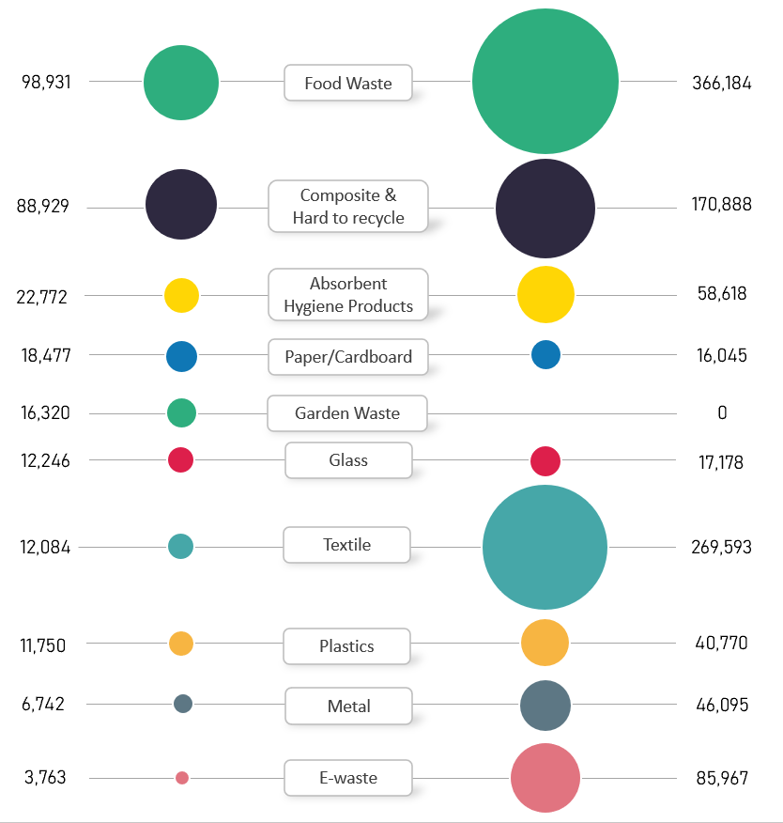
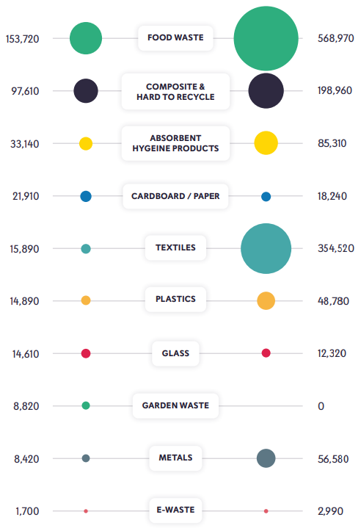
- Impact on Environment Directors Priorities
The Environment Directors priorities were created in September 2022, the business plan delivers on each of the four pillars, prioritising dealing with the financial challenges whilst delivering on climate change.
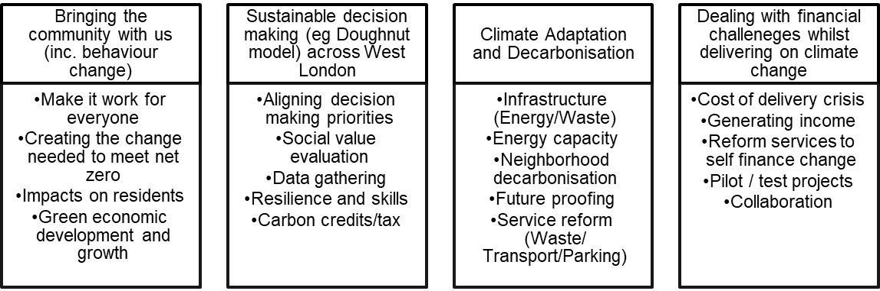
- Impact on Joint Municipal Waste Management Strategy –
The framework agreed in March 2021 is crucial to maintaining focus during this time of uncertain legislation. Progress against the framework demonstrates:
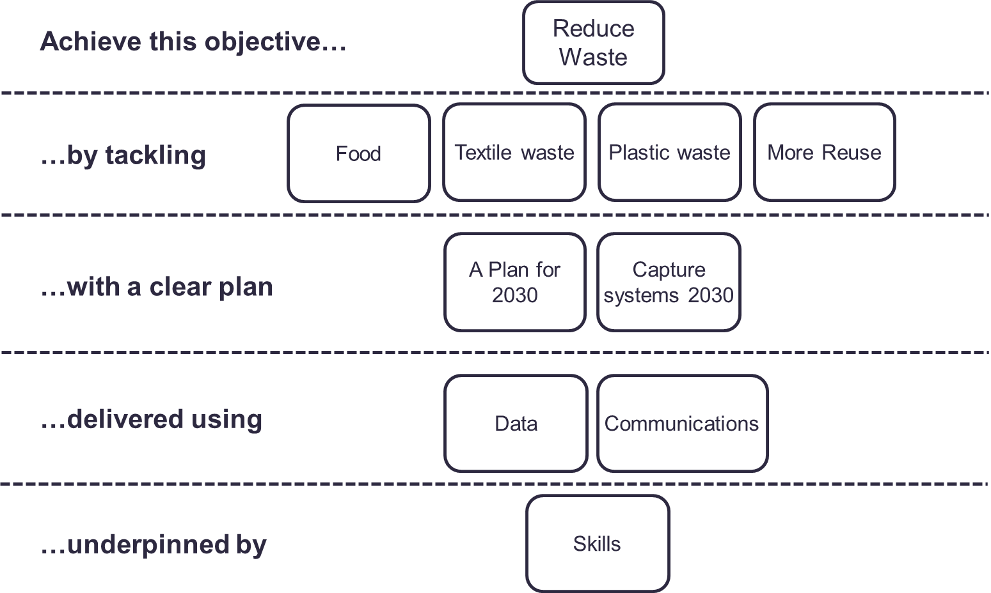
- 18,000 tonnes less waste than pre-pandemic levels.
- A reduction in total food waste and increased participation in food waste recycling from 21% to 24%.
- Kerbside collected textiles increased by 13%.
- Increased reuse of furniture, bicycles, laptops, smart phones and hospital equipment at Abbey Road recycling centre.

Background Papers
 | Emma Beal | Managing Director | 07766 147 978
 |  | emmabeal@westlondonwaste.gov.uk

- Business Plan 2022/23
  - Resilience and preparation
WLWA must be prepared for significant change resulting from legislation and social and economic needs. We must remain aligned with our supply chain and Boroughs as all organisations in the resources and waste sector manage significant change.
Item | Responsible Owner | Outcome | RAG
Training / development opportunities for core skills are prioritised. | Managing Director | Skills plan updated and delivered. Insights and coaching training for all employees carried out and ongoing. Lean Six Sigma white belt for most employees carried out. Data driven decision making training for Managing Director and Finance Director. Power BI training for MI Team. | Green
Chair West London Climate Emergency Officers Group | Managing Director | Group is developing a new plan for 2023, WLA is considering a net zero post to support coordination of activity in West London. Multiple webinars and conference presentations. | Green
A Joint Plan for 2030 | Head of Service Delivery | Legislative matrix and risk assessment created. Hampered by delays to publishing critical Government consultation responses, particularly ‘consistency of collections’. | Amber
Develop an HR Strategy | Finance Director | A draft was developed and agreed with the Treasurer and on 17 February reported to the SLT and the HR Manager for finalisation. Recommend roll over into 23-24 plan with HoSD as lead. | Amber
Prioritising Lean Six Sigma and Data driven decision making for HRRC projects | Head of Service Delivery | Lean Six Sigma and Data Driven Decision Making skills/culture roll-out plans developed. Dashboard developed for monitoring HRRC improvements and shared with Borough Heads of Service and Operations Managers. Data visualisation training rolled out internally to all staff. | Green
Attend and present at West London Treasurer meetings | Finance Director | All WLT meetings have been attended and have included WLWA Updates covering a range of strategic and operational information and have fostered good engagement reflected in discussions and questions. Delivered. | Green
Build partnerships through collaborative procurements | Procurements and Contracts Manager | Procurements delivered for waste transport, green waste management and rubble management, all with a strong carbon and social value focus, and leading to savings. Joint procurement delivered for managing paper and card for several Boroughs, leading to increased savings and strengthened partnerships. | Green
Theme lead for pan-London Reducing Consumption Emissions programme | Project Manager  (E Hall) | Strategy developed targeting reduction/reuse and phasing London wide Borough uptake of WLWA style TRAID textiles/e-waste collections. | Green
  - Projects and Investments
WLWA has invested £3m in food waste projects and £1.2m in HRRC recycling and reuse projects. We must demonstrate the waste reduction and recycling outcomes and build trust in future investment programmes.
Item | Responsible Owner | Outcome
WLWA Finance Strategy. | Finance Director | This was discussed in detail and agreed by both WLT and WLED following a collaborative development process and very successful engagement. This was demonstrated when the Executive Directors recognised and agreed to the Authority retaining a third of PPP income to help deliver wider strategic projects. | Green
Optimise income from the PPP contract | Finance Director | This has involved working closely with both the HoSD and PD to unravel the complex financial implications and relationships between stakeholders. The HoT are now agreed and work on the variation has commenced. | Green
Infrastructure Investment Plan | Finance Director | Identify with partners the range of solutions to upcoming challenges including infrastructure needs. Hampered by legislative delays. | Red
Food Waste Programme | Projects Director | Waste composition completed in Sept 2022. Reported to the March Authority meeting overall food waste arising has dropped from the baseline years and increasing access to more households across the region. | Green
HRRCs waste diversion programme | Operations Manager | Improvements delivered at all Borough sites. Diversion rates are now over 40% at all sites. Key achievements, all saving cost and carbon, include the introduction of rubble recycling at Harrow, separation of bulky and black bag waste at four sites (previously two), an increased reuse offering and introduction of black-bag splitting. | Green
Prepare for EPR, DRS and Consistency impacts on Boroughs | Senior Project Manager | Rerouting and data captured across one borough for collections. Additional data request for the next two boroughs for rerouting. Consistency detail has not been published but will be modelled across the Boroughs once available. | Green
Create a joint Extended Producer Responsibility Strategy with Boroughs | Projects Director | Six Borough agreement in principle on the MTFS for investment and development of infrastructure with additional income. EPR detail not available. | Red
  - Communicating the Vision
WLWA must ensure the link between waste and climate is understood, build partnerships, articulate what success looks like and discuss the steps and challenges with Boroughs and supply chains along the way.
Item | Responsible Owner | Progress to date | RAG
Circular Economy Hub at Abbey Road | Projects Director | Completed for electricals, workshops for bikes and capture of furniture. Additional bikes repaired and sold with Lets Go Southall for delivery back to the community. | Green
Borough Circular Economy Hub | Projects Director | Design and draft business cases. No site available. | Red
Create a virtual circular economy hub | Net Zero Carbon Manager | New website launched in June now has a CE page with local circular economy related information. Draft business directory for website integration/page design outstanding. | Amber
Lead WLWA Strategy Away Days | Head of Service Delivery | First strategy away day delivered on 25 March leading to the framework of a joint plan to 2030. | Green
Procure a communications project to measure baseline and improve levels of understanding in West London of the link between climate emergency, waste and resources. | Net Zero Carbon Manager | Soft market testing completed and options for the procurement model/route and evaluation in draft. | Amber

